

**Faculty of engineering - Shoubra**

**Benha University**

**Research Article / Research Project / Literature Review**

in fulfillment of the requirements of

|  |  |
| --- | --- |
| **Department** | **General** |
| **Division** | **-----------** |
| **Academic Year** | **2019-2020 preparatory** |
| **Course name** | **Computer** |
| **Course code** | **ECE001** |

**Title: -**

**Build a website on recent computer engineering topics** By:

|  |  |  |  |
| --- | --- | --- | --- |
|  | Name | Edu mail | B.N |
| 1 | Eslam Ali Abdelrahman | Eslam195197@feng.bu.edu.eg | 25 |

**Approved by:**

|  |  |
| --- | --- |
| Examiners committee | Signature |
|  |  |
|  |  |
|  |  |
|  |  |
|  |  |

**Research objectives**

It was my choice in this research to write about programming languages, and this is due to my love for programming languages and my love for programming in general, as programming has made life very easy to the extreme and that programming languages are the future and it is upon which many things are built in progress .

**Abstract**

We can put an overview of what the research topic is about (the topic of programming languages). In fact, we can know programming in a simple way as follows:

**Programming :**

Programming is the writing of a set of commands, or what is known as the code or code, and these commands are what constitute what is known as the program, it is what guides and determines its behavior. A computer or electronic device translates and executes these commands.

***We can focus more on programming languages ​​on a programming language called C ++.***

**Introduction**

**As our topic speaks the programming language C ++:**

C Plus is a programming language created in 1983 as an alternative to the C language, and it is very popular because it is usable in different sectors. Including: the financial sectors, games, communications, electronic banking services, retail trade, etc., and the most famous projects that used this language are: Microsoft Windows, Google Chrome, and most Adobe applications, in addition to the Amazon website, and it is considered one of the most powerful languages ​​that exist, and is characterized by its dependence on The basic platform, where the program is implemented in the same operating system in which it was developed.

C++ programming language is a strong programming language :

Actually , we can use book about c++ programming language to know how to

With this language .

C ++ Programming: this book covers the history and characteristics of the programming language as it may be taught in an introductory to advanced course or as a reference book, including information on what is a programming language or how to install a compiler to the most used external libraries, GUI frameworks, design patterns, RAII, Multi-Threading and other information needed for real world programming in C ++.

**Literature Review**

Bjänn Strostrup began work on his C project with varieties in 1979, and he was inspired by the idea of ​​this project while working on his doctoral thesis where he spent a lot of time programming. Strostrup discovered that many features of Simula’s language are indeed appropriate for developing huge software, but the slow performance of applications written in this way was preventing them from being used in a practical way. At the same time, the basic mixed programming language had a good performance but it was low level, enjoying difficult to use in Massive software development. This discovery led Strostrup to the idea of ​​developing a new language that combines the advantages of these two languages.

Strostrup later faced the problem of analyzing the Unix kernel with respect to distributed computing while working at Bell Labs. And he mentions the dilemmas that he faced while working on his thesis. Determined to improve a language, he will use features similar to those in Simula's language. Ströstrup chose C as a common, fast, portable, and commonly used language. In addition to C and Simula, Strostrup has inspired a number of other languages: 68 Ghouls, Definition Language (ML), Chloe (Programming Language), and Ida.

Ströstrup worked on developing a bank called "C-Front" that converts a C ++ source to an equivalent C source, through which he used some new features to the C language such as classes, derived classes, strong profiling, inclusion, and default values. The first commercial release of C ++ was launched on October 14, 1985.

In 1983 the name of the language was changed from «C with classes» to C ++ (where ++ is the coefficient of increase in C language) and a set of features like virtual dependencies, overloading of parameters and functions, references, constants, and managed memory control were added By user, optimize patterns,

and line comments using two slashes (//) on mixed basic programming language style. In 1985 the first edition of the C ++ Programming Book was published to provide programmers with one of the most important references for this language at a time when the language has not yet been identified as an official standard. The book was published in 1989, version 2.0 of the book was published, and in 1991 the updated second edition was published. New features included multiple genetics, abstract varieties, static member functions, and constricted members. 1990 A detailed C ++ guide (Annotated C ++ reference guide) was published and was the cornerstone of a future language standard. Subsequent features included templates, exceptions, name spaces, and new conversions between styles and boolean style.

The development of the C ++ language has been associated with the development of the standard library. The I / O library (I / O stream) is the first addition to the standard library. This library provides alternatives to custom C input and output functions such as printf and scanf. One of the many successive additions to the Standard Template Library (Standard Template Library) is one of the most important additions to the Standard Library. It includes the C ++ language from the rest of the languages ​​due to the limited number of keywords, as the basic functionality was included in the standard library similar to the C language.C ++ is sometimes known as a hybrid language due to the availability of many different programming models and their availability to use these models with each other, such as using the procedural and purpose-oriented model while writing the same program. The possibility of writing procedural programs using C ++ has sparked some controversy considering that it is supposed to write purpose programs to gain access to C ++ (otherwise C would not be used Dear). In all cases, it is usual to combine the procedural and purpose-oriented models when writing a program. This causes some problems while checking the source or completing the source writing by another programmer.

C ++ is still widely used as one of the preferred languages ​​for developing professional applications .

***The origin of the C ++ designation:***

"The name confirms the evolutionary nature of the changes made to the C language," Strostrup says. "During the development phase, C ++ was unofficially called the" new C "and then the name changed to" C with varieties. " The credit for the final designation (C ++) goes back to Rick Macetti (mid-1983), and he used this designation for the first time in December 1983. When Masetti was asked in 1992 about the reason for naming the language with this name he replied that he did it out of joking. The origin of the name is due to the use of the plus sign (++) from the C language, which increases the value of the variable assigned to it and the common use of the (+) symbol to indicate an improvement in a computer program. The joke is that the name itself contains an error: that the use of the subsequent increase causes the variable to increase after evaluating the previous value of the variable (unlike the previous increase in the sense that the C ++ language is not better than the C language, otherwise it was better to use the previous increase so that it becomes The name of the C ++ language instead of using the suffix as in the current name.

There is no language called “C +,” although there is a completely different language called + ABCL / c. There are some languages ​​that are named near C ++, the most famous being C- and C-Sharp.

Screenshots of pages :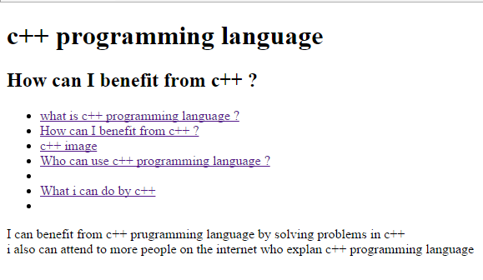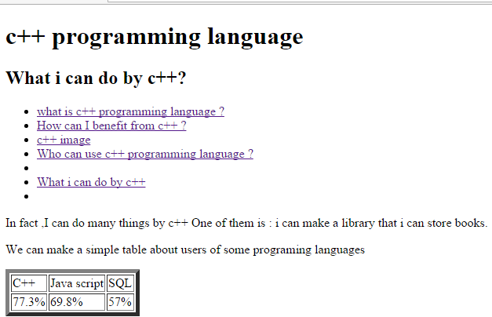

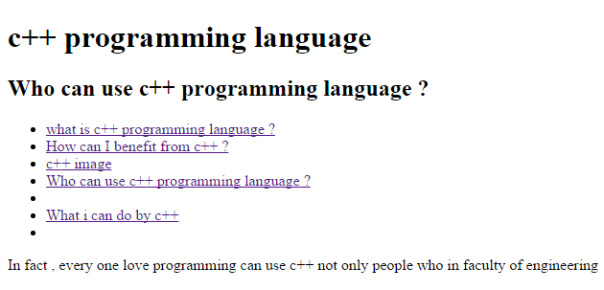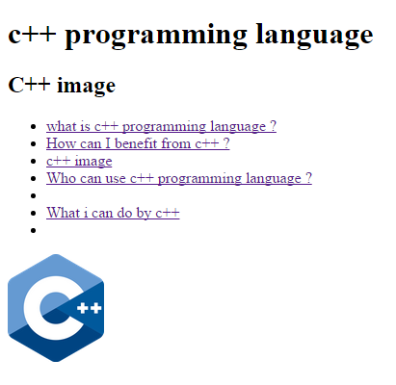

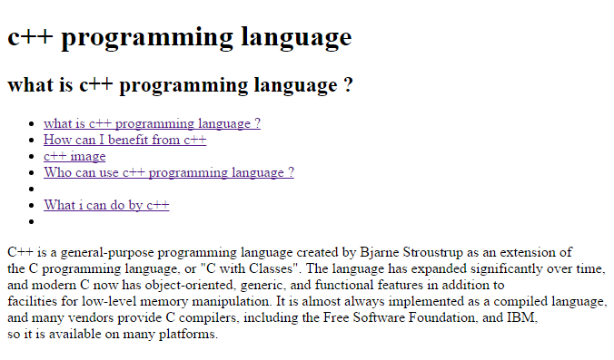

**Screen shots of source code:**

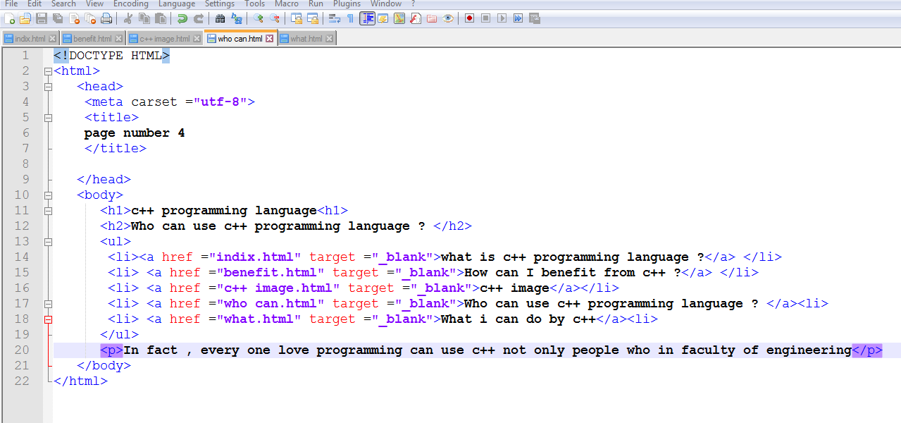

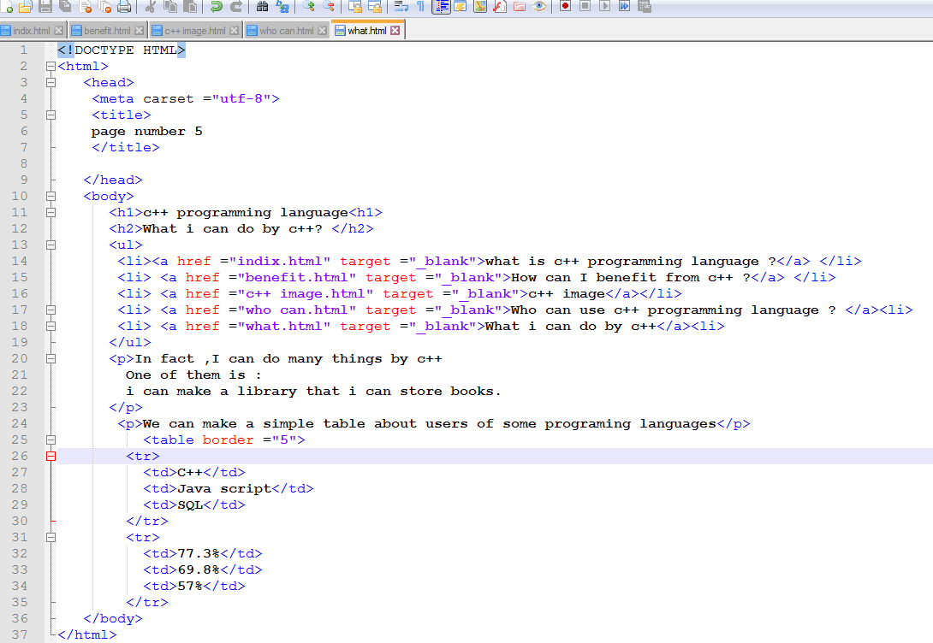

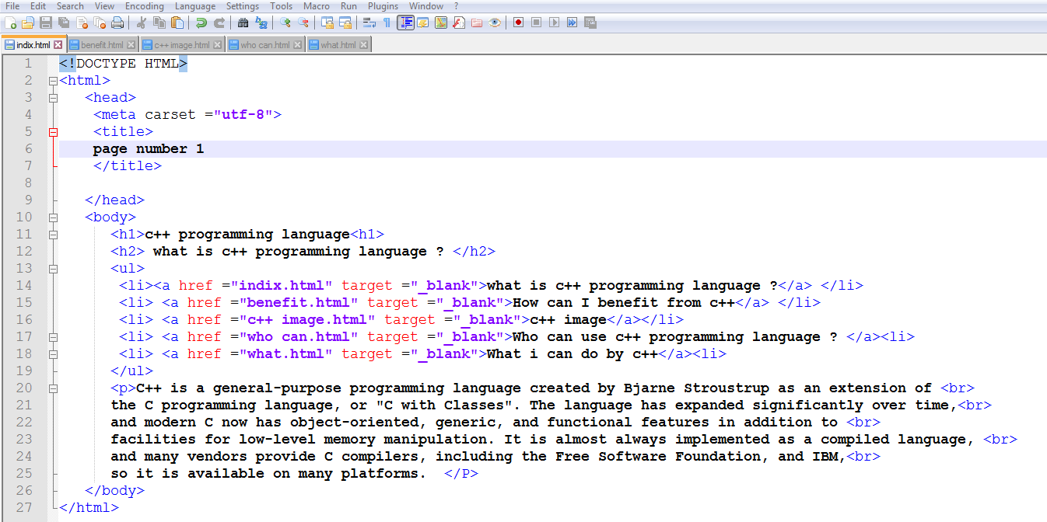

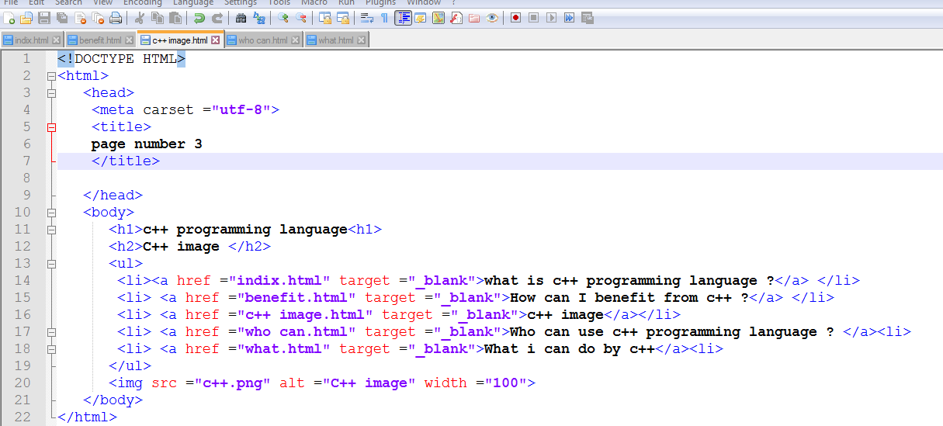

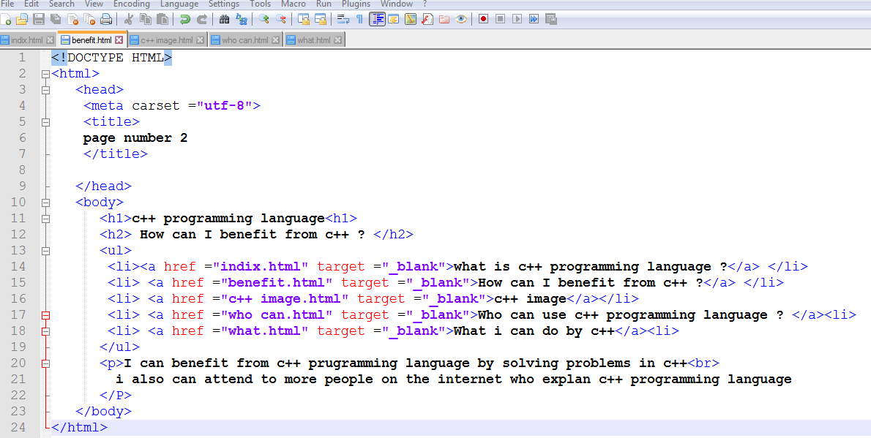

**Gethub link :**

**Gethub publish link:**

**Results and discussion**

The benefit that I am most accustomed to doing of this research (programming language research) which was about a programming language called C ++

I learned what the C ++ language is, and while it is used, the really C ++ programming language is used in many fields and I have talked about it in this research with some simplified detail about the C ++ programming language and I also learned some history about the C ++ programming language how It was created and why programmers claimed to invent a programming language called C ++ and why was this name used especially?

And this talk also I mentioned in the research, but I could not write everything about this great language, the C ++ programming language, but I have clarified some important points concerning the C ++ programming language.

Finally, I can clarify something that I discovered while doing this research:

Computer programming languages are similar to human languages in that they have alphabets and rules governing formulas. Programs written in computer languages are entered into programs called translators that examine the commands of these programs and their full compliance with the rules governing the formulations of the languages in which they are written. The translated program converts the program written in one of the computer languages to the language of the deity in case all the commands are correct .

**Conclusions**

In fact , I was known when I search about c ++ programming language I was known that c ++ programming language is a good language for the beginners and if the beginner Master this programming language he can learn any programming language after that because a lot of programming languages are similar in more things so as we mention if any one Master this programming language he can easily learn more programming languages .

----------------------------------------------------------------------------------------------------

**References**

Egyptian Knowledge Bank : <https://www.ekb.eg/ar/home>

**Layout and formatting**

**(Guide, don’t include this page in your research)**

Use this template

**Paper:** A4

**Margins:** 2.5 cm all from top and bottom

**1.**9 cm from left and right

**Line spacing:** 1.5

**Font:** Time New Roman

**Font size:** 14 (Except headings)

**No of pages:**Between 5 and 10 pages (Not including cover)